


Stage 2 of the
DIF/DS/DBO Danish Championships 2025
for iQFOiL Open and Formula Foil
Venø Efterskole, May 24-25th 2025
1 | RULES
1.1 | The event is governed by the rules as defined in The Racing Rules of Sailing including the prescriptions of Nordic Sailing Federation and Danish Sailing Association.
1.2 | Furthermore, the following applies:  RSS Appendix B except B5 61.1 and B8.A8  RRS Appendix T,  Statutes for the Danish Championships in Sailing,  DBO-CR-iQFOiL-Open-Formula-Foil-Championship-Rules-2025.docx  DBO-ER-iQFOiL-Open-Formula-Foil-Equipment-Rules-2025.docx  Notice of Race
2 | NOTICES TO COMPETITORS
2.1 | Notices to competitors will be posted on the official notice board(s) located in the Danish Championships WhatsApp Group.
3 | SIGNALS MADE ASHORE
3.1 | Signals made ashore will be displayed at the official flagpole located on the spot mentioned on the Skippers’ meeting.

4 | SCHEDULE
4.1 | See NoR
5 | CLASS FLAGS
5.1 |   iQFOiL 7-8-9  (and Formula Foil):
6 | RACING AREAS
6.1 | Depending on the wind direction, the racing area can change. However, it will be within the area shown in addendum A. The exact racing area will be shown at the skippers’ meeting each day.
6.2 | For Slalom and Course Racing, the race area will be in the waters close to the island, as shown at the skippers’ meeting on Sunday.
6.3 | For Marathon, the race area is around the island of Venø.
7 | THE COURSES
7.1 | The diagrams in Addendum A show the courses, the order in which marks are to be passed, and the side on which each mark is to be left.
7.2 | On Saturday, Marathon races will take place. Either two separate races, each of one tour around the island, or one race rounding the island once or twice, depending on the wind conditions. It will be announced on skippers’ meeting as it is depending on wind conditions.

8 | TARGET TIMES
8.1 | Time limits and target times [in minutes] are as follows:  Discipline Target time Finish window  iQFOiL Course Racing 16 +100% of 1st board  iQFOiL Slalom 4-5 +100% of 1st board  iQFOiL Marathon 60 +100% of 1st board  Failure to meet the target times will not be grounds for redress. This changes RRS 62.1(a).
9 | SAFETY REGULATIONS
9.1 | Check-Out and Check-In: If instructed by the race committee, all sailors must check-out and check-in before and after the Marathon Race. The standard penalty applied for breaking this instruction will be 1 point for each of the relevant races.
9.2 | If instructed by the race committee, all sailors must carry a cell phone for the Marathon Race. The standard penalty applied for breaking this instruction will be 1 point for each of the relevant races.
9.3 | A boat that retires from a race shall notify the race committee as soon as possible. The standard penalty applied for breaking this instruction will be 1 point for the relevant race.

ADDENDUM A
RACING AREA

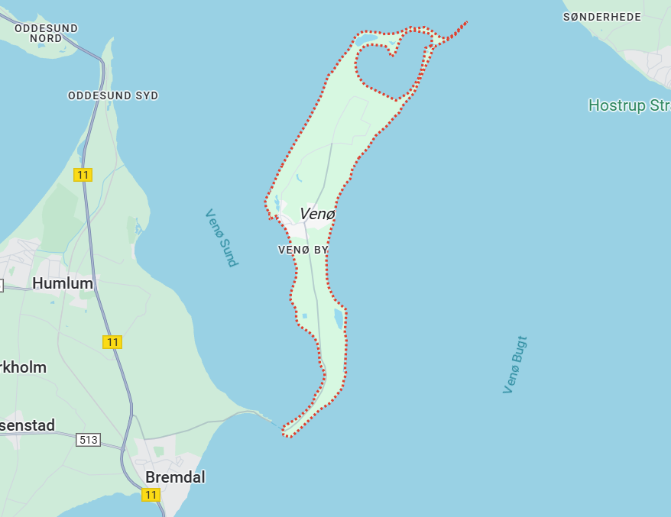
ADDENDUM B
COURSE DIAGRAMS
Expected angles and lengths available in the iQFOiL Class Race Management Guidelines.

Bouys and flagpoles can be changed. On skippers’ meeting will be told how they will look.

COURSE (9+ kts)

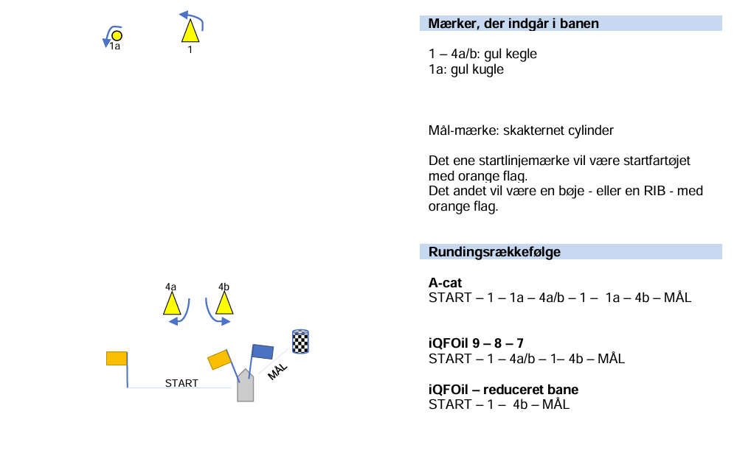

SPRINT SLALOM (apprx 5-15 kts)
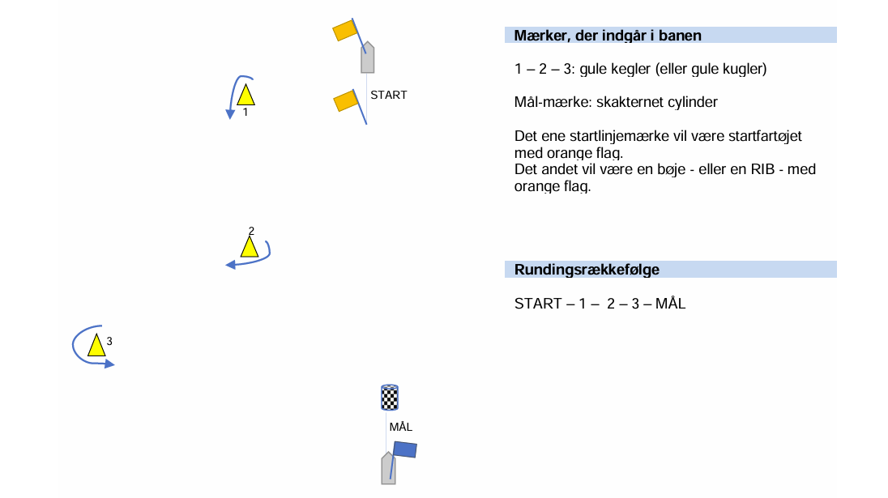

U-SPRINT (apprx 5-15 kts)
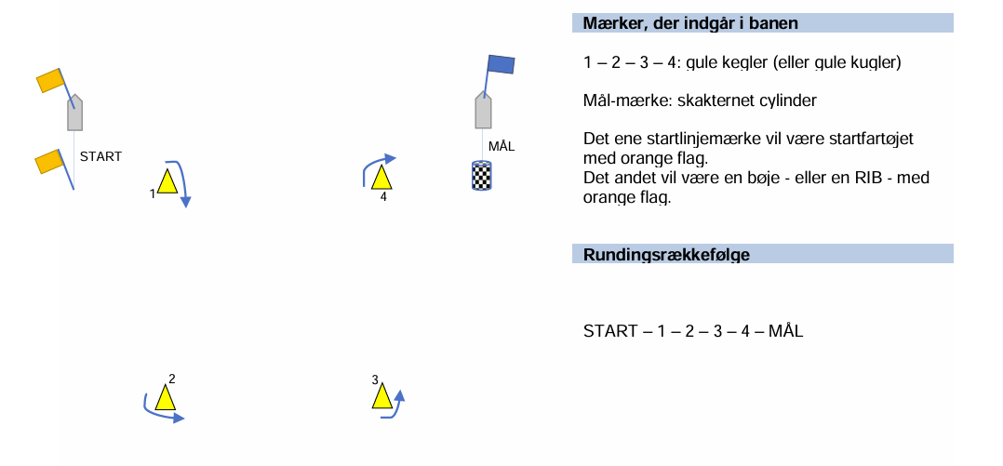
MARATHON

Will be around the island of Venø- On skippers’ meeting the exact route will be disclosed.

